Rachelle Muyargas October 07, 2023

4533324

PROG1124-G11

**Class Activity – 4**

**Array**

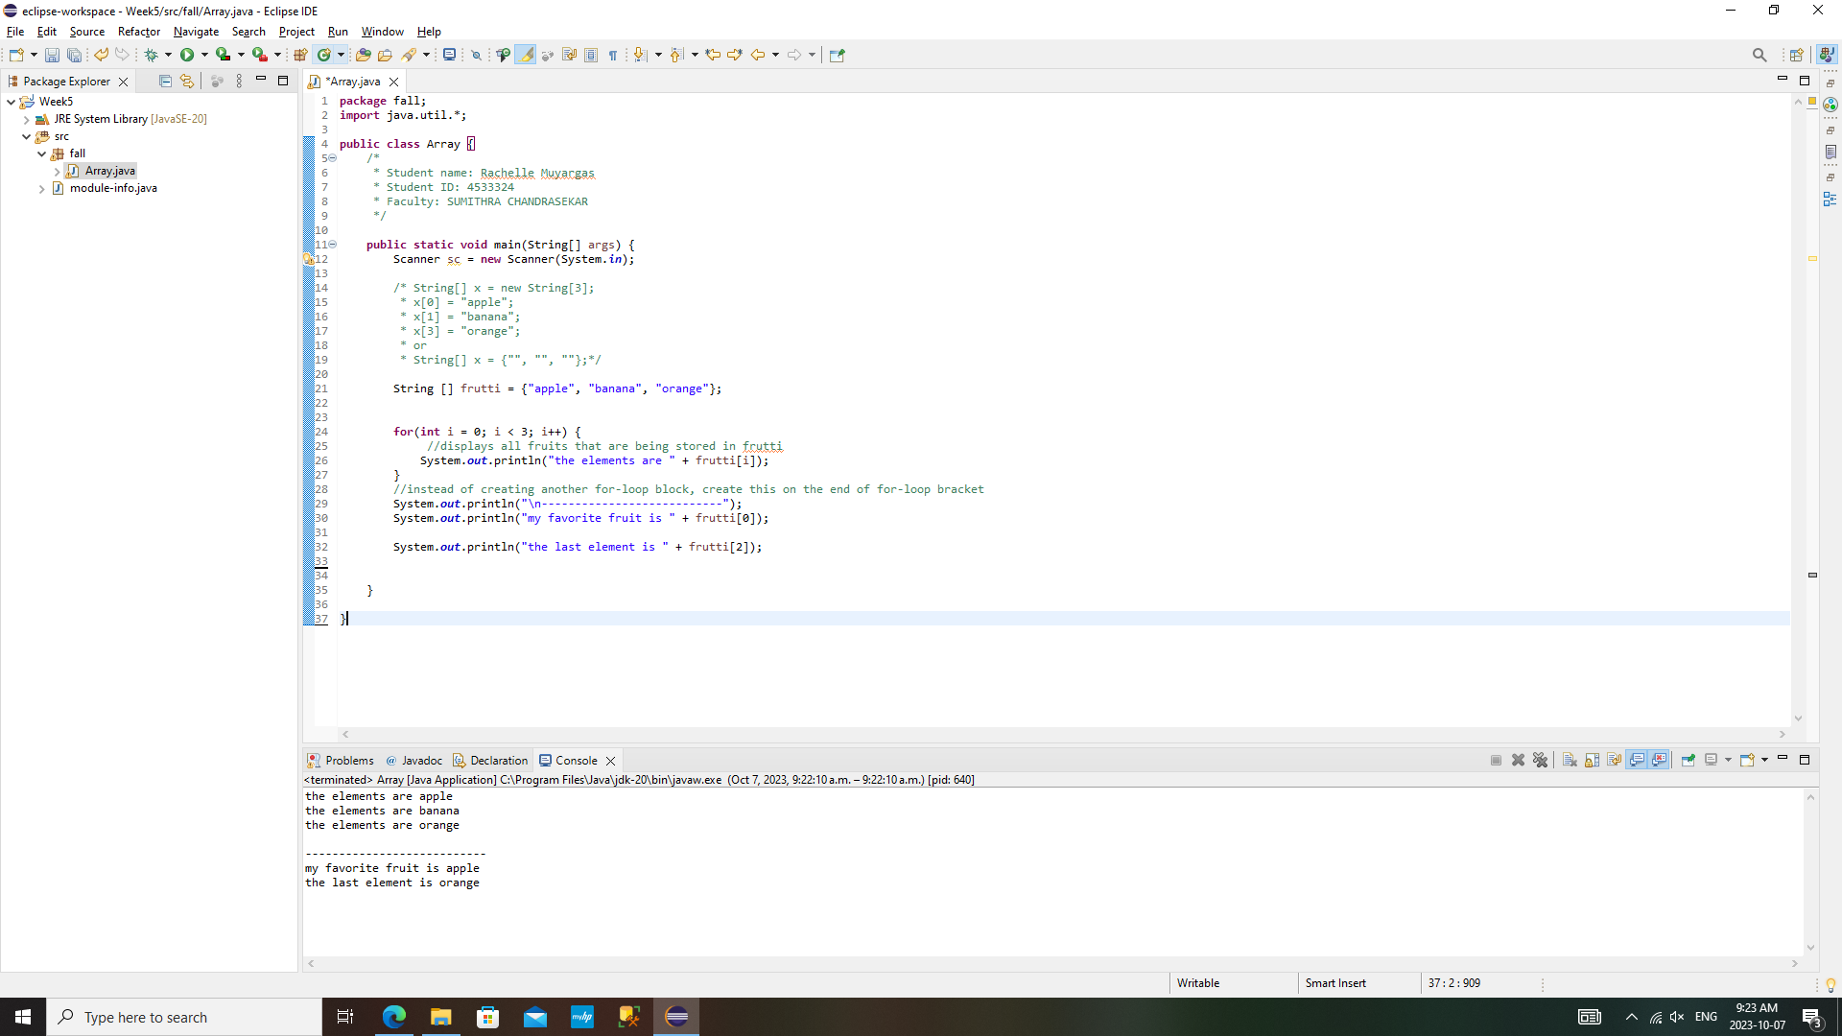*Array.java*

*Output*

***Array***

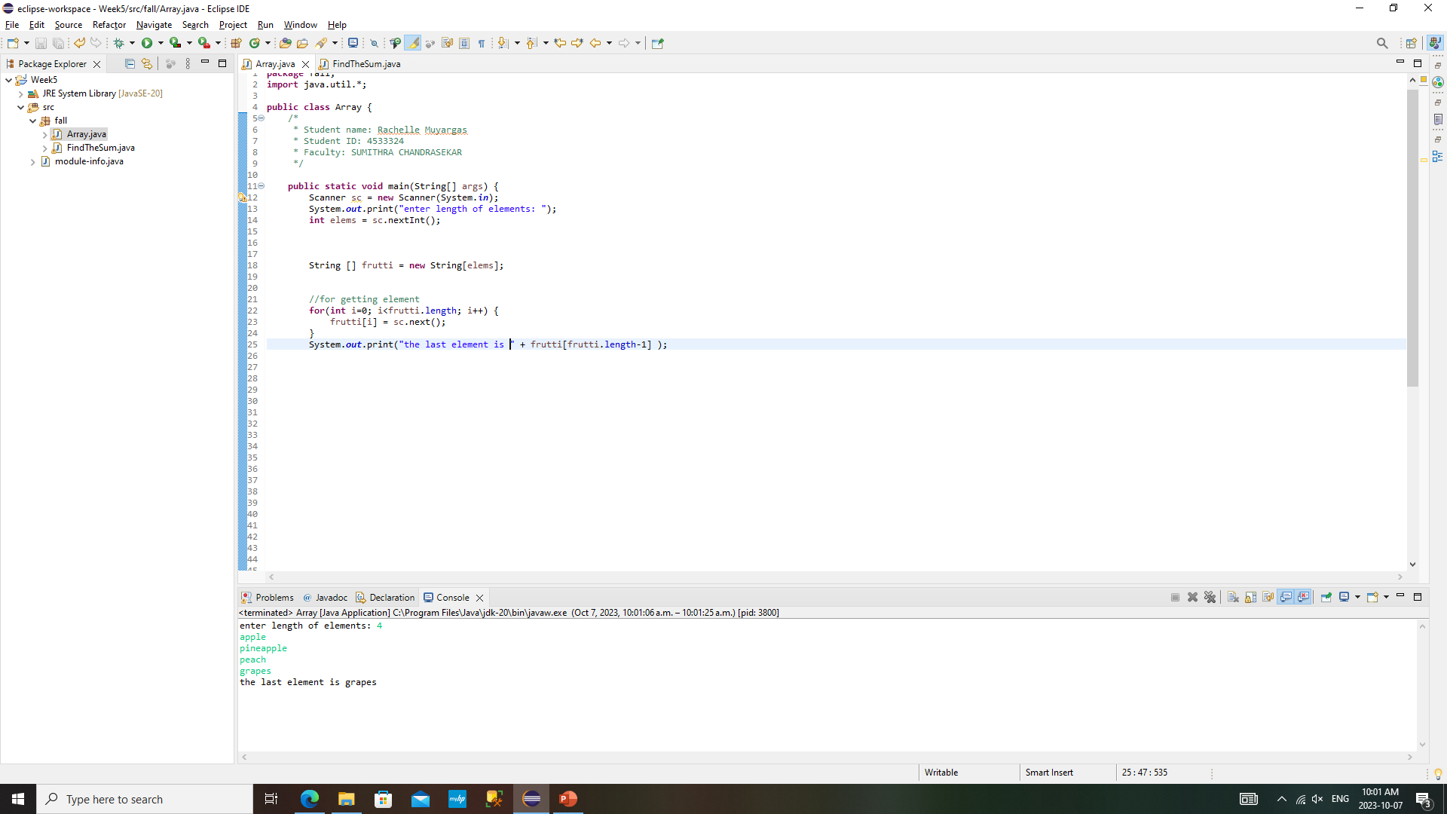

*Output*

**Find the Sum**

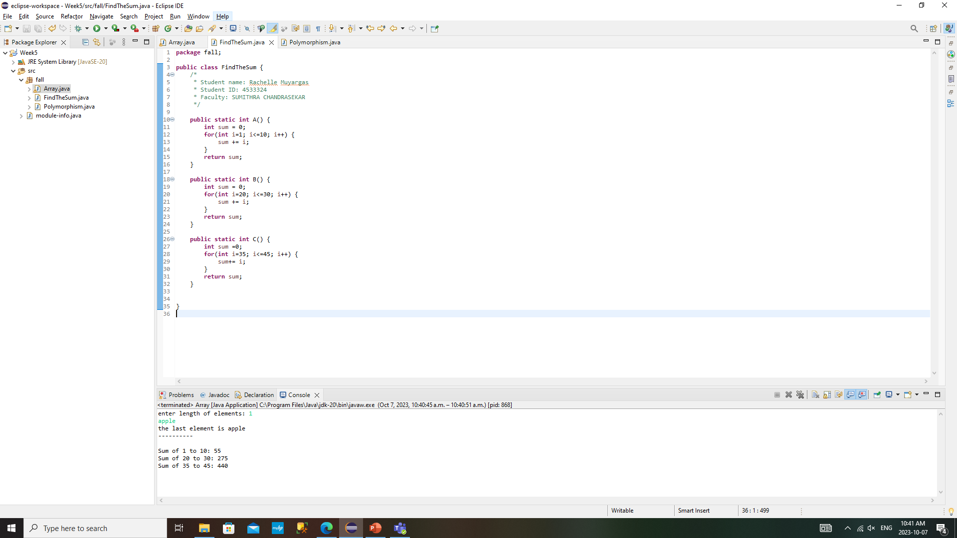*FindTheSum.java*

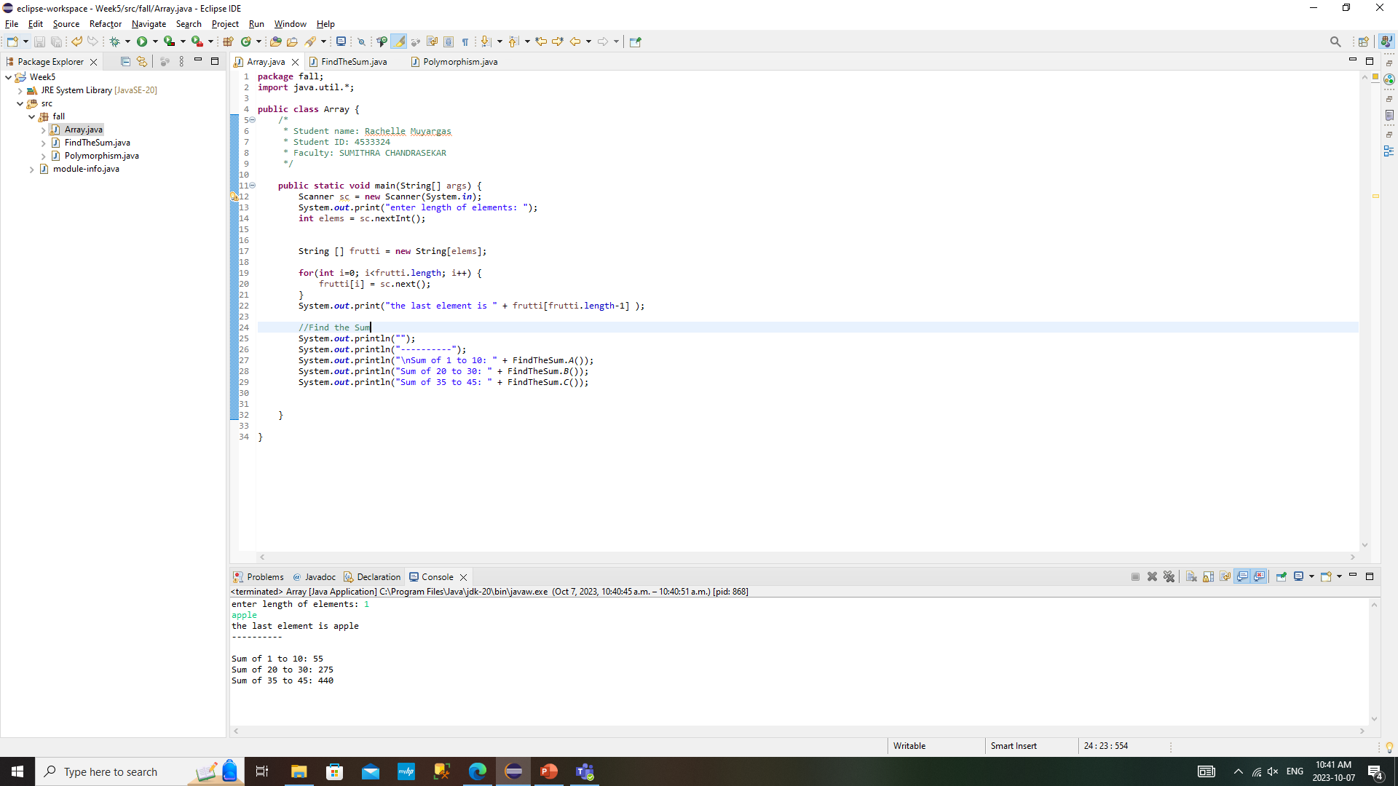

*Output*

**Polymorphism**

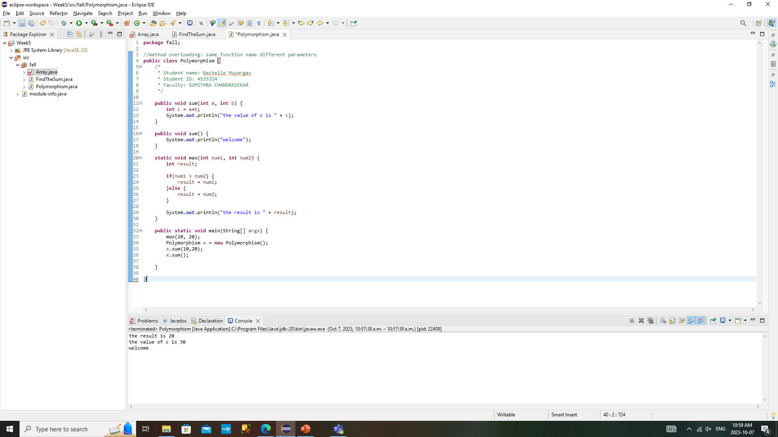

*Polymorphism.java*



*Output*

**GitHub**

<https://github.com/grumpyjoo/rachmuyargas.git>

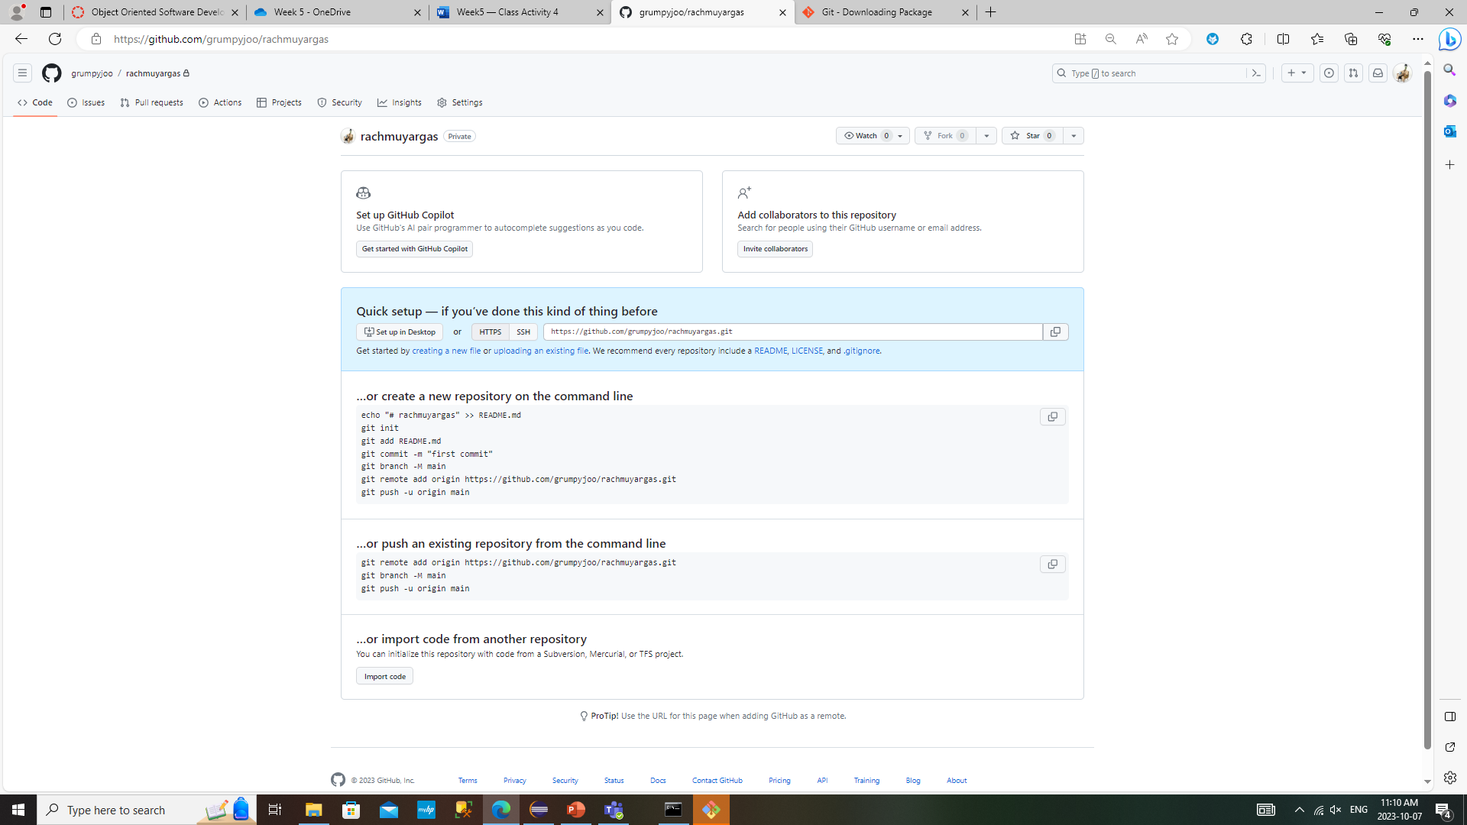

Click creating new file/ uploading an existing file

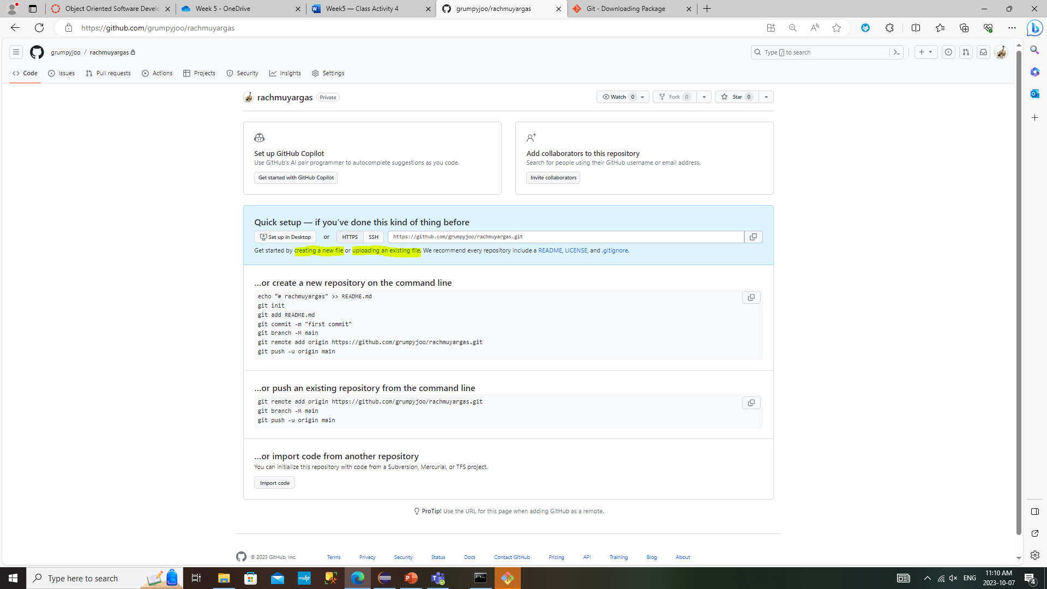

Click choose your files

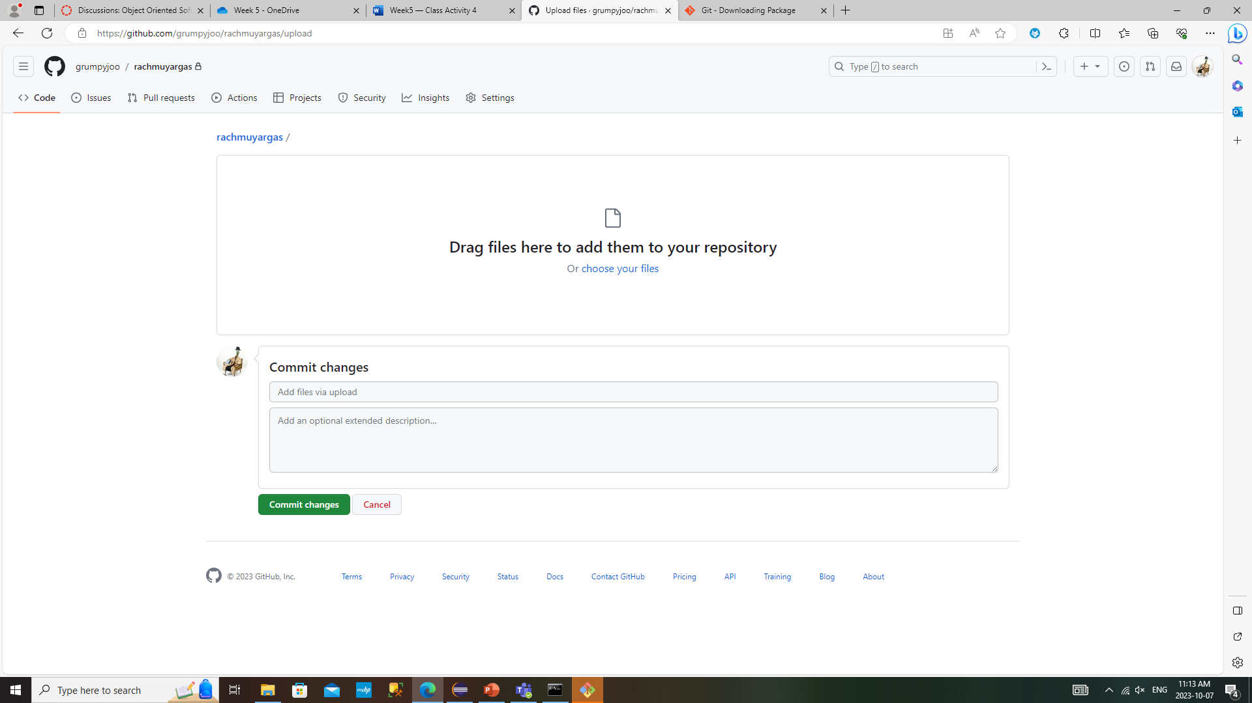

Click commit changes button

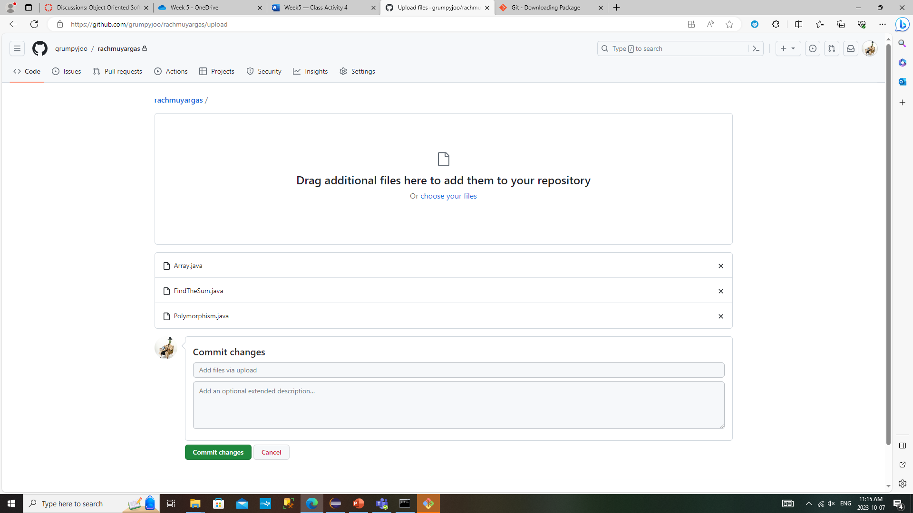

Here are the files I uploaded

